Task 1
Aim: To find the second highest number from a given list of integers.
Algorithm:
- Read the integer N (number of elements).
- Read N space-separated integers and store them in a list.
- Use Java 8 Stream API to:
- Remove duplicate elements using distinct().
- Sort the elements in descending order.
- Skip the first (highest) element.
- Retrieve the next element (second highest).
- If the second highest element exists, print it.
- Otherwise, print -1.
Program:
import java.util.*;
import java.util.stream.*;

public class SecondHighest {

public static void main(String[] args) {
Scanner sc = new Scanner(System.in);

// Read number of elements
int n = sc.nextInt();

// Read list elements
List<Integer> list = new ArrayList<>();
for (int i = 0; i < n; i++) {
list.add(sc.nextInt());
}

// Find second highest using Stream API
Optional<Integer> secondHighest = list.stream()
.distinct()
.sorted(Comparator.reverseOrder())
.skip(1)
.findFirst();

// Print result
if (secondHighest.isPresent()) {
System.out.println(secondHighest.get());
} else {
System.out.println(-1);
}

sc.close();
}
}
Out Put:
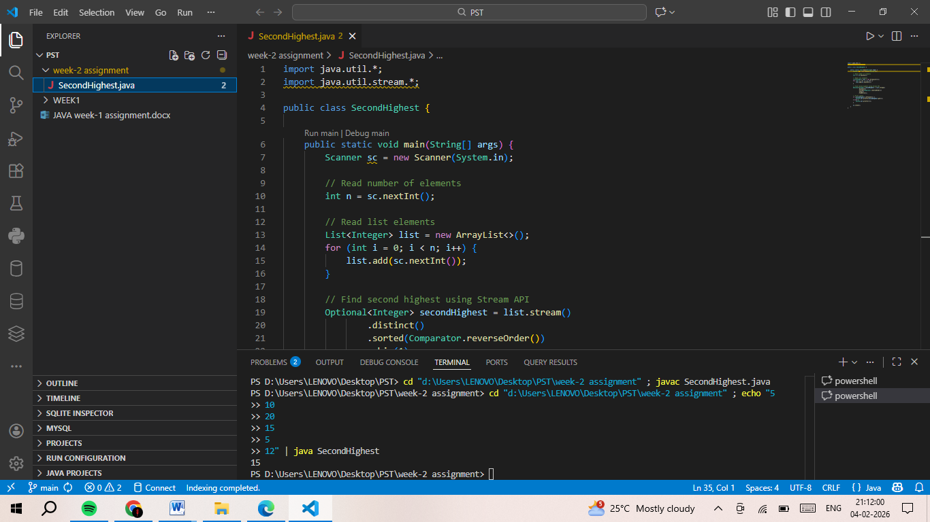

TASK 2
Aim: To demonstrate the use of functional interfaces and lambda expressions in Java to check whether a given number is odd or even, prime or composite, and palindrome or not, based on the user’s choice.
Alogorithm:
- Define a functional interface PerformOperation with a method check(int a).
- Create a class MyMath that:
- Implements isOdd() using a lambda expression to check odd numbers.
- Implements isPrime() using a lambda expression to check prime numbers.
- Implements isPalindrome() using a lambda expression to check palindrome numbers.
- Define a static method checker() that takes a PerformOperation and an integer, and returns the result of the operation.
- In the main() method:
- Read the number of test cases T.
- For each test case:
- Read the choice (ch) and the number (num).
- Based on ch:
- If ch == 1, check whether the number is odd or even.
- If ch == 2, check whether the number is prime or composite.
- If ch == 3, check whether the number is a palindrome.
- Display the corresponding result for each test case.
Program:
import java.io.*;
import java.util.*;
import java.util.function.*;

interface PerformOperation {
boolean check(int a);
}

class MyMath {

public static boolean checker(PerformOperation p, int num) {
return p.check(num);
}

PerformOperation isOdd() {
return n -> n % 2 != 0;
}

PerformOperation isPrime() {
return n -> {
if (n <= 1) return false;
for (int i = 2; i <= Math.sqrt(n); i++) {
if (n % i == 0) return false;
}
return true;
};
}

PerformOperation isPalindrome() {
return n -> {
String s = String.valueOf(n);
return s.equals(new StringBuilder(s).reverse().toString());
};
}
}
public class Solution {
public static void main(String[] args) throws Exception {
MyMath ob = new MyMath();
BufferedReader br = new BufferedReader(new InputStreamReader(System.in));
int T = Integer.parseInt(br.readLine());

while (T-- > 0) {
String[] parts = br.readLine().split(" ");
int ch = Integer.parseInt(parts[0]);
int num = Integer.parseInt(parts[1]);

PerformOperation op;
boolean ret = false;

if (ch == 1) {
op = ob.isOdd();
ret = MyMath.checker(op, num);
System.out.println(ret ? "ODD" : "EVEN");
}
else if (ch == 2) {
op = ob.isPrime();
ret = MyMath.checker(op, num);
System.out.println(ret ? "PRIME" : "COMPOSITE");
}
else if (ch == 3) {
op = ob.isPalindrome();
ret = MyMath.checker(op, num);
System.out.println(ret ? "PALINDROME" : "NOT PALINDROME");
}
}
}
}
Out Put:
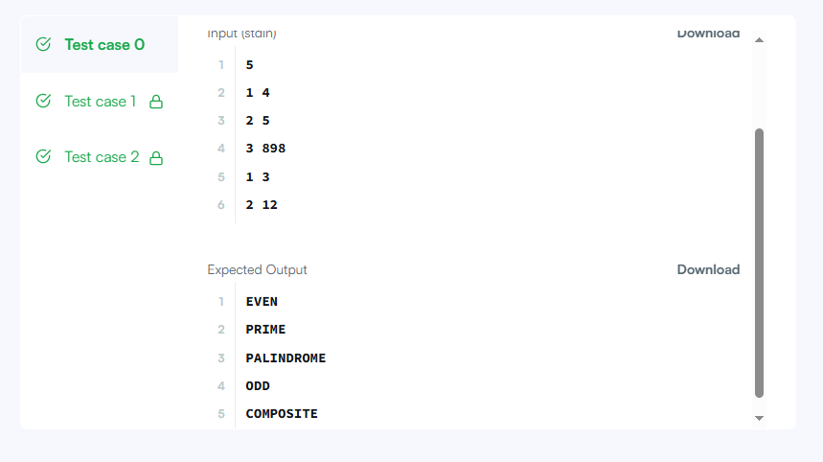

TASK 3
Aim : To write a Java program that calculates and prints the minimum sum and maximum sum of exactly four out of five integers given in a list.
Algorithm :
- Read 5 integers from the user and store them in a list.
- Initialize:
- totalSum to store the sum of all elements.
- min to store the minimum element.
- max to store the maximum element.
- Traverse the list:
- Add each element to totalSum.
- Update min if the current element is smaller.
- Update max if the current element is larger.
- Compute:
- minSum = totalSum − max (sum of the smallest four numbers)
- maxSum = totalSum − min (sum of the largest four numbers)
- Print minSum and maxSum separated by a space.
Program :
import java.util.*;
class Result {
public static void miniMaxSum(List<Integer> arr) {
long totalSum = 0;
int min = Integer.MAX_VALUE;
int max = Integer.MIN_VALUE;
for (int i = 0; i < arr.size(); i++) {
int val = arr.get(i);
totalSum += val; // [cite: 55]
if (val < min) min = val;
if (val > max) max = val;
}
long minSum = totalSum - max;
long maxSum = totalSum - min;
System.out.println(minSum + " " + maxSum); // [cite: 61]
}
}
public class Solution {
public static void main(String[] args) {
Scanner scanner = new Scanner(System.in);
List<Integer> arr = new ArrayList<>();
for (int i = 0; i < 5; i++) {
arr.add(scanner.nextInt());
}

Result.miniMaxSum(arr);
scanner.close();
}
}
Out Put :
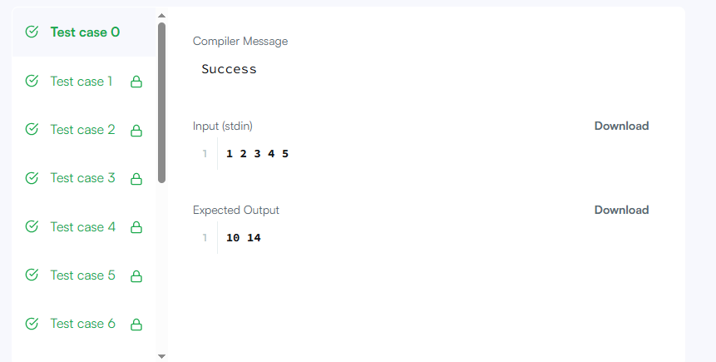

Task 4
Aim: Sort the persons alphabetically by name using method references.
Algorithm:
- Read integer n (number of persons).
- For each person:
- Read name and age.
- Store them in a Person object.
- Read ageLimit.
- Sort the persons alphabetically by name using a method reference.
- Filter persons whose age is greater than ageLimit using a static method reference.
- Convert all names to uppercase using an instance method reference.
- Print:
- Sorted names.
- Names of persons older than ageLimit.
- All names in uppercase (original order).
Program:
import java.util.*;
class Person {
String name;
int age;
Person(String name, int age) {
this.name = name;
this.age = age;
}
public String getName() {
return name;
}
public int getAge() {
return age;
}
public static boolean isOlderThanLimit(Person p, int limit) {
return p.age > limit;
}
}

class PersonStreamDemo {

public static void main(String[] args) {
Scanner sc = new Scanner(System.in);

int n = sc.nextInt();
List<Person> persons = new ArrayList<>();

for (int i = 0; i < n; i++) {
String name = sc.next();
int age = sc.nextInt();
persons.add(new Person(name, age));
}

int ageLimit = sc.nextInt();
persons.stream()
.map(Person::getName)
.sorted(String::compareTo)
.forEach(name -> System.out.print(name + " "));
System.out.println();
persons.stream()
.filter(p -> Person.isOlderThanLimit(p, ageLimit))
.map(Person::getName)
.forEach(name -> System.out.print(name + " "));
System.out.println();
persons.stream()
.map(Person::getName)
.map(String::toUpperCase)
.forEach(name -> System.out.print(name + " "));
System.out.println();

sc.close();
}
}
Out Put:
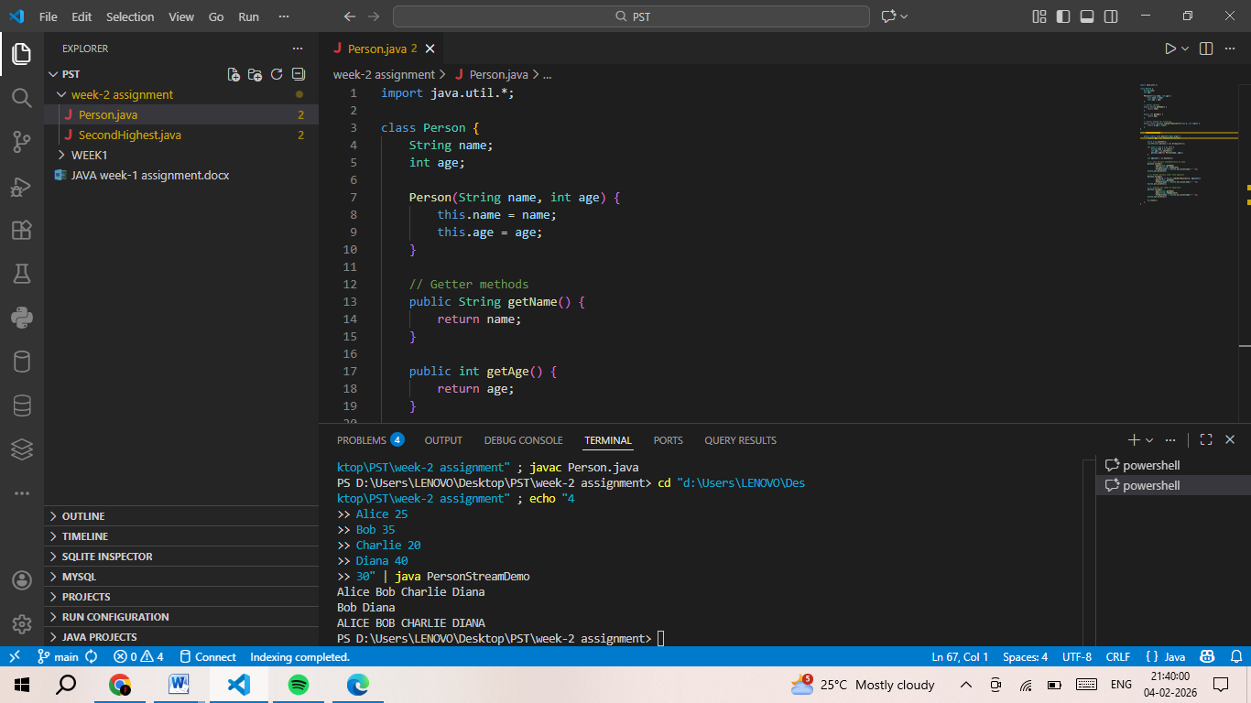

TASK 5
Aim : To write a Java program that finds the length of the longest substring without repeating characters in a given string.
Algorithm:
- Create a variable maxLen and set it to 0.
- Use a loop to select each character as a starting point (i from 0 to s.length()-1).
- Create a boolean array seen[256] to track ASCII characters.
- Initialize currentLen = 0.
- Use another loop (j from i to end of string):
- Get the character ch = s.charAt(j).
- If seen[ch] is true, break the loop (duplicate found).
- Otherwise:
- Mark seen[ch] = true.
- Increment currentLen.
- Update maxLen = max(maxLen, currentLen).
- After checking all starting positions, return maxLen.
Program:
class Solution {
public int lengthOfLongestSubstring(String s) {
int maxLen = 0;

// Try every possible starting position
for (int i = 0; i < s.length(); i++) {
boolean[] seen = new boolean[256]; // ASCII characters
int currentLen = 0;

// Expand from position i
for (int j = i; j < s.length(); j++) {
char ch = s.charAt(j);
if (seen[ch]) {
break; // Stop when repeat found
}
seen[ch] = true;
currentLen++;
maxLen = Math.max(maxLen, currentLen);
}
}
return maxLen;
}
}
Out Put:

TASK 6
Aim: To write a Java program that counts the number of digits present in a given integer.
Algorithm:
- AlgInitialize a variable count to 0.
- Repeat the following steps while the number n is greater than 0:
- Increment count by 1.
- Divide n by 10 to remove the last digit.
- When n becomes 0, stop the loop.
- Return the value of count, which represents the total number of digits in the given number.orithm:
Program:
public class Solution {

public static int allDigitsCount(int n) {
int count = 0;
while (n > 0) {
count++;
n = n / 10;
}
return count;
}
}
Out Put: 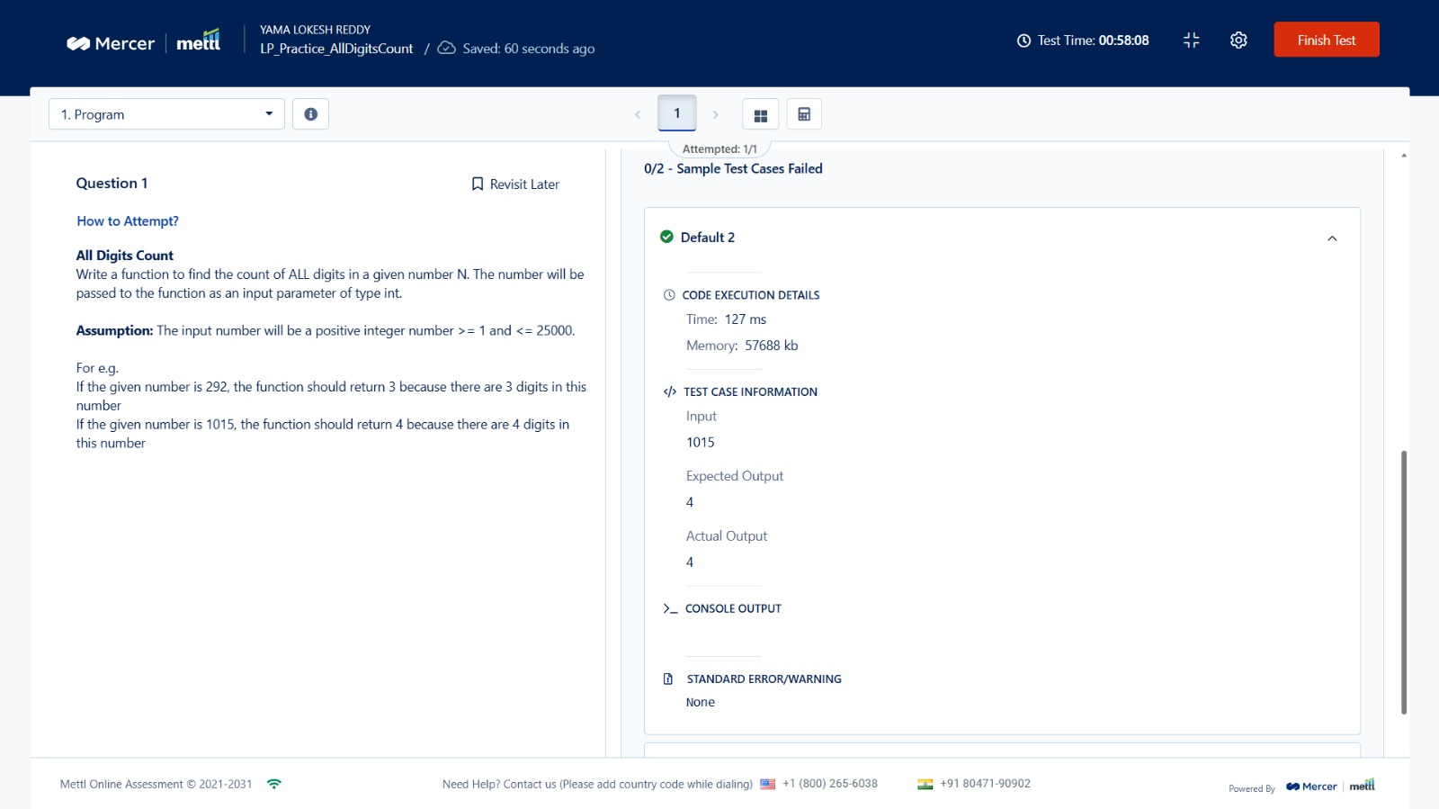
TASK 7
Aim : To write a Java program that determines the day of the week for a given date (day, month, and year) using the Calendar class.
Alogorithm:
- Read the month, day, and year from the user.
- Create an instance of the Calendar class using Calendar.getInstance().
- Set the date in the calendar using:
- month - 1 (because months in Calendar start from 0).
- Retrieve the day of the week using Calendar.DAY_OF_WEEK.
- Store the names of the days (SUNDAY to SATURDAY) in a string array.
- Map the obtained day value to the corresponding day name from the array.
- Display the day of the week in uppercase.
Program:
import java.util.Calendar;
import java.util.Scanner;

class Result {
public static String findDay(int month, int day, int year) {
Calendar cal = Calendar.getInstance();
cal.set(year, month - 1, day);
int dayOfWeek = cal.get(Calendar.DAY_OF_WEEK);
String[] days = {
"SUNDAY", "MONDAY", "TUESDAY", "WEDNESDAY",
"THURSDAY", "FRIDAY", "SATURDAY"
};
return days[dayOfWeek - 1];
}
}

public class Solution {
public static void main(String[] args) {
Scanner scan = new Scanner(System.in);
int month = scan.nextInt();
int day = scan.nextInt();
int year = scan.nextInt();
scan.close();

System.out.println(Result.findDay(month, day, year));
}
}
Out Put:
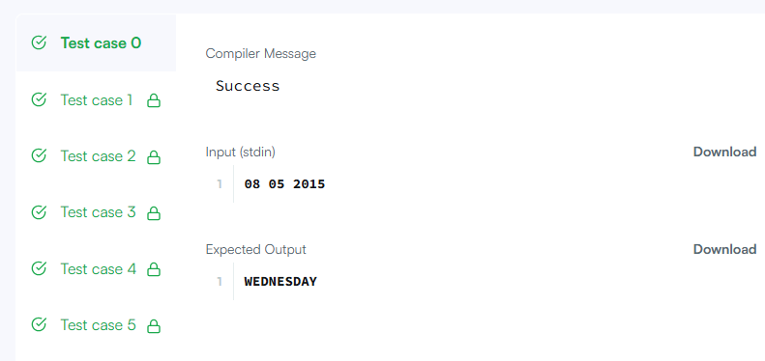

Task 8
Aim: To write a Java program that calculates the total weight of a hill pattern
Algorithm:
- Start the program.
- Read the number of levels (levels).
- Read the weight of the head level (headWeight).
- Read the incremental weight value (increment).
- Initialize totalWeight to 0.
- For each level i from 1 to levels:
- Calculate the number of stars as i.
- Calculate the weight of each star as
  - headWeight + (i - 1) × increment.
- Multiply stars with weight per star and add it to totalWeight.
- After processing all levels, display totalWeight.
- Stop the program.
Program:
import java.util.Scanner;

public class HillPatternWeight {

public static int totalHillWeight(int levels, int headWeight, int increment) {
int totalWeight = 0;

for (int i = 1; i <= levels; i++) {
int stars = i;
int weightPerStar = headWeight + (i - 1) * increment;
totalWeight += stars * weightPerStar;
}

return totalWeight;
}

public static void main(String[] args) {
Scanner sc = new Scanner(System.in);

int levels = sc.nextInt(); // input1
int headWeight = sc.nextInt(); // input2
int increment = sc.nextInt(); // input3

System.out.println(totalHillWeight(levels, headWeight, increment));
}
}
Out Put :

TASK 9
Aim: The goal is to process this list using Java’s date and time to perform the following operations.
Algorithm:
- Read integer N (number of events).
- For each event:
- Read event name and date string.
- Parse the date string into a LocalDate object.
- Store the data in an Event object.
- Read the month number.
- Sort the list of events by date using Comparator.comparing().
- Display sorted event names.
- Find:
- Earliest event using min()
- Latest event using max()
- Filter events whose month matches the given month number.
- Display the required outputs.
Program:
import java.time.LocalDate;
import java.util.*;
import java.util.stream.*;

class Event {
String name;
LocalDate date;

Event(String name, LocalDate date) {
this.name = name;
this.date = date;
}

public String getName() {
return name;
}

public LocalDate getDate() {
return date;
}
}

class EventDateProcessing {

public static void main(String[] args) {
Scanner sc = new Scanner(System.in);

int n = sc.nextInt();
List<Event> events = new ArrayList<>();

for (int i = 0; i < n; i++) {
String name = sc.next();
String dateStr = sc.next();
LocalDate date = LocalDate.parse(dateStr);
events.add(new Event(name, date));
}

int month = sc.nextInt();
List<Event> sortedEvents = events.stream()
.sorted(Comparator.comparing(Event::getDate))
.collect(Collectors.toList());

sortedEvents.forEach(e -> System.out.print(e.getName() + " "));
System.out.println();
Event earliest = sortedEvents.stream()
.min(Comparator.comparing(Event::getDate))
.get();
System.out.println(earliest.getName());
Event latest = sortedEvents.stream()
.max(Comparator.comparing(Event::getDate))
.get();
System.out.println(latest.getName());
events.stream()
.filter(e -> e.getDate().getMonthValue() == month)
.forEach(e -> System.out.print(e.getName() + " "));

sc.close();
}
}
Out Put:
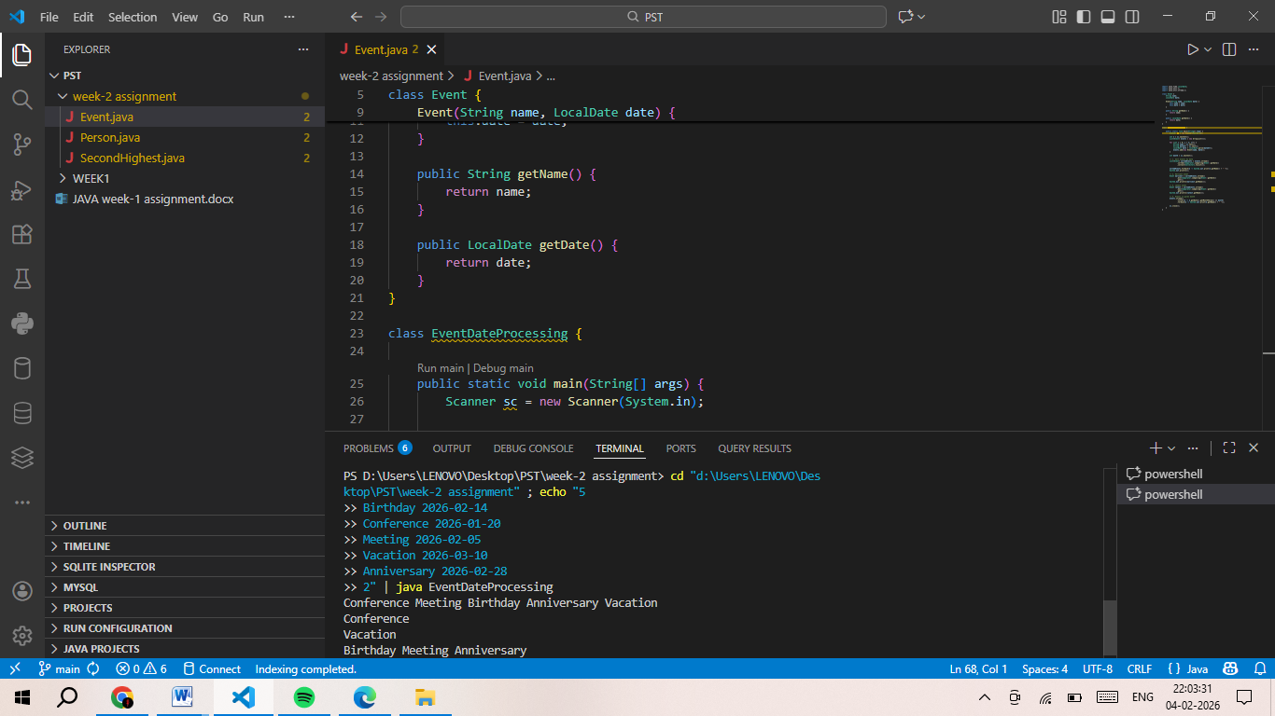

Task 10
Aim: To write a Java function that counts the total number of digits present in a given integer.
Algorithm:
- Accept an integer input1.
- Create a variable count and initialize it to 0.
- This variable will store the number of digits.
- Repeat the following steps while input1 > 0:
- Divide input1 by 10 (input1 = input1 / 10).
- Increment count by 1.
- This removes the last digit in each iteration.
- After the loop ends (when input1 becomes 0), return count.
Program:
import java.io.*;
import java.util.*;

// Read only region start
class UserMainCode
{
public int allDigitsCount(int input1){
// Read only region end

int count = 0;

while(input1 > 0){
input1 = input1 / 10;
count++;
}
return count;
}
}

